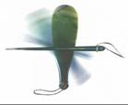
Mana Pounamu 2017 Evaluation Form

Name: (optional) ____________________________________________________
School: ___________________________________________________________

Three things I really liked about Mana Pounamu 2017:

Three changes I think would improve Mana Pounamu 2018:

Any other comments?

Kia ora mai – your feedback is much appreciated.
Please email your completed evaluation form to the Mana Pounamu Kōmiti Whakahaere at: mana.pounamu@gmail.com

